**ASSIGNMENT-9.3**

**Course: AI Assisted coding**

**Name: B. Divya Sri**

**HT NO: 2403A51425**

**Batch- 16**

**Task 1:**

**Prompt:**

write a program in python that finds the addition of odd and even numbers from the list 1 to 10 without doc strings and inline comments.

**Code:**

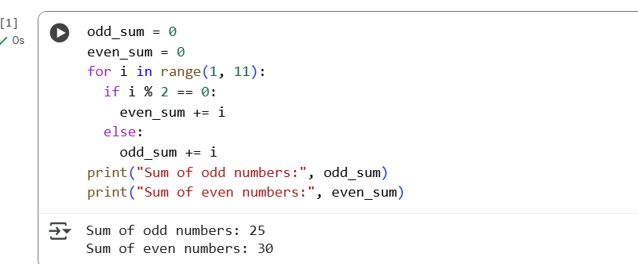

**Adding doc strings:**

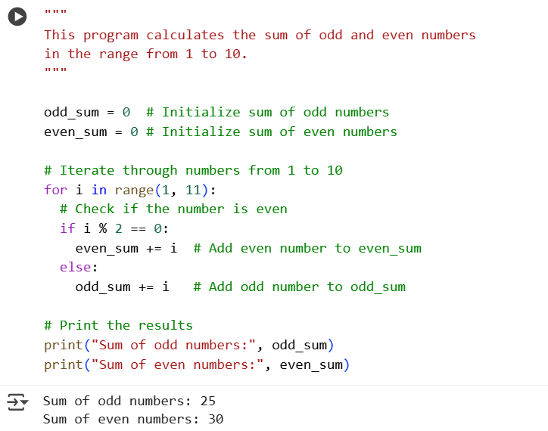

**Task 2:**

**Prompt:**

write a program in python to create a class name sru_student with attributes like name,roll_no,hostel_fee without doc string and inline comments

please add fee_updates method and display_details method. please add sample names and attributes details and display it.

**Code:**

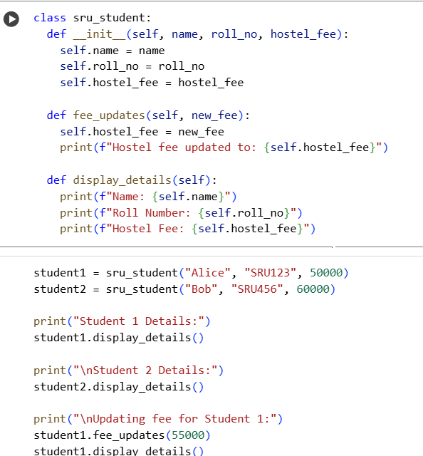

**Adding doc strings:**

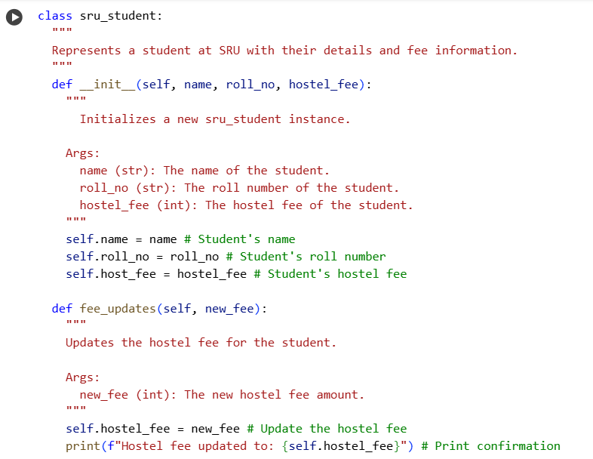

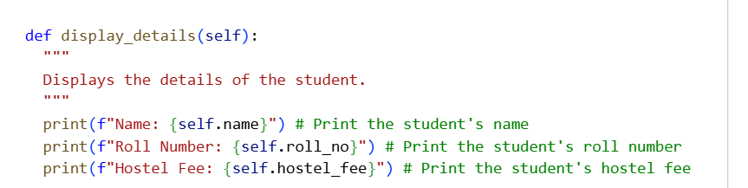

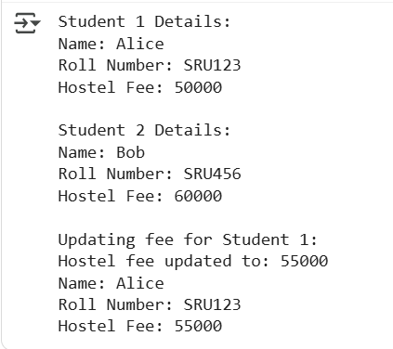

**Task 3:**

**Prompt:**

write a program in python with 3-4 functions like add,subtract,multiply ,divide based on user input without doc strings and inline comments.

**Code:**

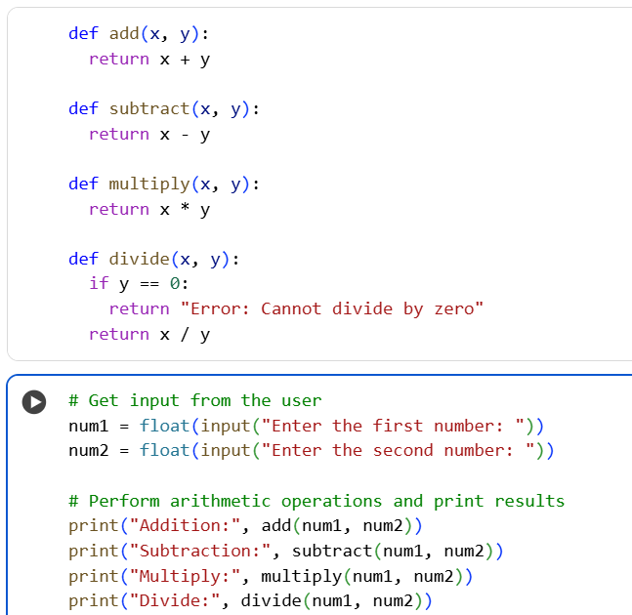

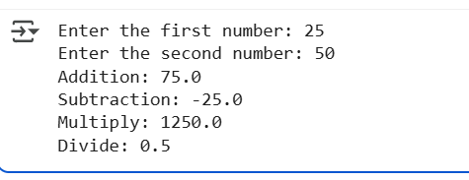

**Adding doc strings:**

